Chapter 18, Problem 3.

Calculate the Fourier transform of the signal in Fig. 18.28.

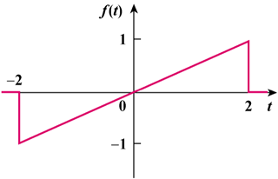

Figure 18.28
For Prob. 18.3.

